Abstract class

Workshop #7

Flutter Developer Bootcamp

# **Purpose**

This workshop demonstrate the concept of inheritance and method overriding in Dart, a programming language primarily used for developing mobile, desktop, server, and web applications. It also helps understand how to structure code using inheritance, abstract classes, and method overriding to create flexible and reusable code components.

**Problem**

In the given workshop demonstrates the inheritance and method overriding in Dart. The abstract class Calculation has an abstract method getValue and a concrete method addition. The Answer class extends Calculation, providing an implementation for getValue while inheriting the addition method. In the main function, instances of Answer call these methods, showcasing object-oriented principles like abstraction, inheritance, and code reusability. You need to create subtraction method.

**How to Solve**

1. Checkout the workshop from Git Repo:

git clone -b <user-branch> <repo-URL>

1. Open the root folder inside VS Code
2. Open the root folder in terminal
3. Run the command dart run filename.dart
4. Abstract Class (Calculation):

* Abstract method getValue
* Concrete method addition
* New concrete method subtraction

1. Concrete Subclass (Answer):

* Overrides getValue
* Inherits addition
* Inherits subtraction

1. Main Function:

* Initializes variables x and y
* Creates an Answer object
* Calls getValue, addition, and subtraction methods

1. Go To File: <specific-file--method> à <method-name>, implement your logic.

**You will Achieve**

When you complete this workshop you will learn the following:

**Methods and Functions Used:**

* **Abstract Method:**
* void getValue(int x, int y);
* **Concrete Methods in Calculation:**
* void addition(int x, int y): Prints the sum of x and y.
* void subtraction(int x, int y): Prints the difference between x and y.
* **Overridden Method in Answer:**
* @override void getValue(int x, int y): Prints the values of x and y.

# **Screenshots**

## **Before implementation (without substraction)**

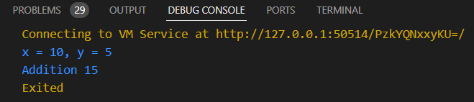

## **After implementation (with substraction)**

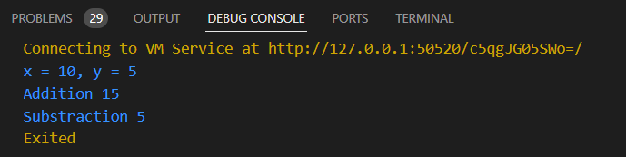

# **How to submit your workshop**

Push your project back to the same git branch using command:

<command name>

# **Happy Coding!**